**Fillable Table Resource**

**Strengthening Resilience and Public Engagement in Aquatic Resource-Related Grant Applications**

This fillable table is intended to help applicants[1] of aquatic resource-related grants strengthen their proposals by including ecological resilience and public engagement considerations. It expands a table developed in a [collaboration with EPA Region 9](https://www.epa.gov/adaptation-organon/region-9-wetland-program-development-grants) (R9) to help writers of Wetland Program Development Grant (WPDG) proposals better address these priority areas in their proposals. The original table, found in R9’s Fiscal Year 2023-2024 WPDG Request for Applications ([RFA; pages 11-12](https://www.epa.gov/system/files/documents/2023-10/epa-regix-wpdg-23-24-final.pdf)), provides:

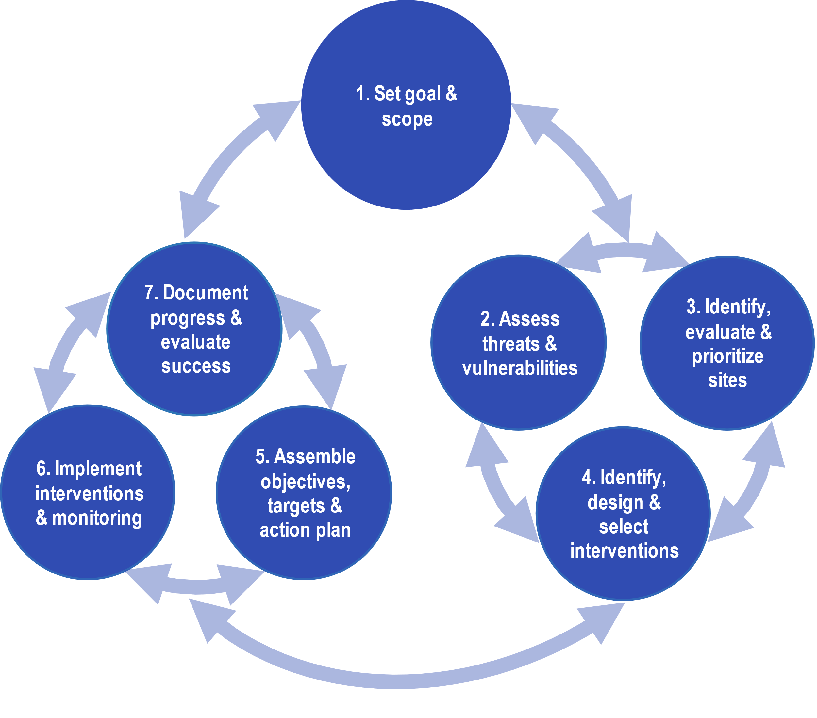

***Figure 1.*** *The EPA* [*Organon*](https://www.epa.gov/organon) *is a collaborative framework for resilience planning*

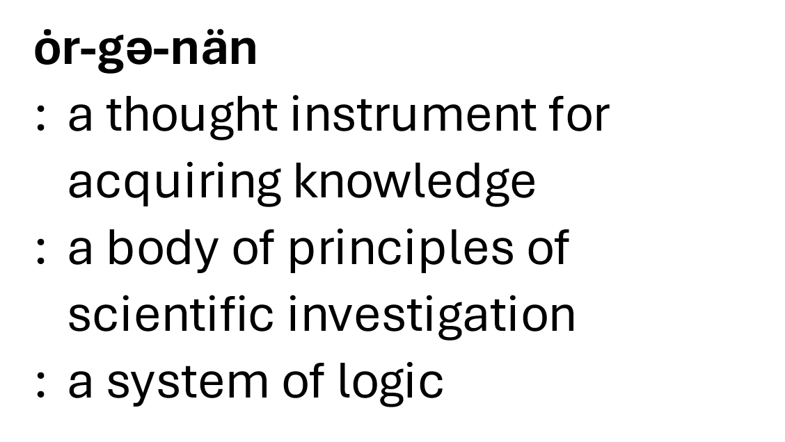

* A listing of key components of resilience-based planning based on EPA’s [Organon](https://www.epa.gov/organon) (Figure 1), focusing on wetland program development (steps 1-5)
* Concepts and example ideas for including priority resilience and public engagement considerations in WPDG proposals

The updated table below (Table 1) offers similar but more broad guidance that is expanded to include all seven steps and designed to be useful to anyone applying for a grant in aquatic (or other natural resource) research, management, and program development. The first column lists the Organon key components ([steps](https://www.epa.gov/organon/explore-steps)) of resilience planning and implementation, followed by second and third columns with information on ecological resilience and public engagement considerations specific to each step. A brief explanation in each cell is followed by a bulleted list of specific examples of resilience- and engagement-based considerations that could be used to strengthen resilience planning in proposals.

The bulleted lists can be edited. Users can keep examples that fit their needs, delete those that do not, and add new ideas based on their proposals. The table is not comprehensive but rather provides a variety of ideas for creative thinking. Bullets can be used as-is or changed, turned into sentences, and transferred to the proposal where needed.

***Table 1.***[*Organon*](https://www.epa.gov/organon) *components of planning and implementation, with ideas for how to address climate resilience and environmental justice in aquatic resource grant proposals*

|  |  |  |
| --- | --- | --- |
| **Organon Components of Planning & Implementation** | **Example Ecological Resilience Considerations** | **Example Public Engagement**  **Considerations** |
| **1. Set Goal & Scope** | Include in the **goal and scope** statement what the aquatic resource study, protection, or restoration will accomplish under ongoing environmental changes. For example: | **Scope** could include aquatic resources that are, for example: |
| * Restored structure, function, and resilience to extreme events in a specific geographic area * Specified timeframe adequate to evaluate a measurable increase in resilience * Robustness indicators (e.g., water quality, species richness, survival rates) as measures of effectiveness | * In outlying geographic areas * Of high community value * Associated with at-risk communities * Supporting fishing and hunting * Critical to local economies |
| **2. Assess Threats & Vulnerabilities** | Assess **threats** of local and large-scale environmental change stressors to the aquatic resource of interest as well as its **vulnerability** to exposures and capacity to resist or recover. For example: | Assess with communities their **vulnerabilities** to inter-related economic and ecological factors. For example: |
| * Evaluate the vulnerabilities of aquatic resource condition, function, and area * Include direct physical impacts of storms, wildfires, and heat waves * Include interactive effects through factors such as changing precipitation, floods, and droughts | * Reliance on services provided by aquatic resources (e.g., flood control, fisheries, wildlife habitat) * Unequal tradeoffs among regulatory options * Lack of consideration of local knowledge |
| **3. Identify, Evaluate & Prioritize Sites** | Whether an **identified site** has already been selected or multiple sites will be **prioritized**, site **evaluation**(s) should consider, for example: | Site-specific **evaluation** could also include specific community impacts and outreach needs. For example: |
| * Vulnerability assessment information on environmental change exposures and aquatic resource resilience at site(s) * Expected effects of exposures and resilience on the current and future status of site(s) * Implications of the above for site suitability for achieving monitoring, restoration, or other goals | * Social risk indicators and data on communities impacted by the site(s) * Inclusion in the site selection process of relevant public stakeholders such as impacted, invested, and outlying communities |
| **4. Identify, Design & Select Interventions** | When developing **interventions**, include strategic **design** considerations, with **selection** based on effectiveness under both current and future conditions. For example: | Include working with local communities to ensure that **selected interventions** achieve particular community needs. For example: |
| * Analyze current effectiveness of different aquatic resource interventions, e.g., to reduce erosion and support migration to prevent marsh “drowning” * Consider how environmental change impacts (e.g., sea level rise, stronger storms) could necessitate design changes * Select and use interventions that will function effectively under long-term environmental change | * Providing benefits (e.g., jobs, improved mental health, safety) to at-risk groups * Mitigating risks (e.g., flooding, fisheries habitat loss, water contamination) * Aligning with community values |
| **5. Assemble Objectives, Targets & Action Plan** | Use information from the previous steps to inform site- and intervention-specific **objectives** and stepwise **targets** for reaching them. This includes, for example: | **Action plan** elements for working collaboratively with communities could include, for example: |
| * Crafting objectives that are “SMART” (specific, measurable, achievable, relevant, and time-bound) * Establishing targets for achievable biological or physical conditions given environmental changes * Building practical timelines and staffing that will allow for adjustments to future changes | * Building local capacity by highlighting areas for community involvement * Establishing objectives consistent with community priorities, lifestyles, and capacity |
| **6. Implement Interventions & Monitoring** | **Implementation** of aquatic resource activities occurs via initial pilot trials (if needed) that are then scaled-up, with **monitoring** used to inform adjustments to address environmental changes through time. This includes, for example: | Support local communities in establishing a sense of responsibility and ownership over **implementation**, increasing the probability of long-term success by: |
| * Timing and sequencing of activities that take into account environmental change factors and effects * Monitoring before, during, and following actions to measure environmental change effects as well as system responses to management interventions * Including indicators of resilience and robustness in monitoring plans | * Tapping into community networks to spread awareness of opportunities in which to be involved or give feedback * Designating project roles to community volunteers and leaders to help with implementation * Using mutually agreed-upon metrics that are clear and fit the community context |
| **7. Document Progress & Evaluate Success** | **Evaluation** involves tracking effectiveness of **progress** (i.e., carrying out actions as planned) and **success** (i.e., reaching aquatic resource goals) according to targets. This includes, for example: | Work with community members to define what project **progress** and **success** look like with respect to agreed-upon goals and priorities. This can be achieved by: |
| * Assessing impacts of environmental changes on the ability to carry out project actions * Assessing effects of environmental changes on detecting or achieving targeted changes in the aquatic resource * Evaluating project status in terms of concrete advancements toward, and eventual achievement of, the original goal(s), including the role of environmental changes in when/how/whether goal(s) have been met | * Setting expectations early and often, including communicating possible project limitations * Establishing channels for public feedback and adapting success metrics as needed * Maintaining transparency and outlining how the intervention(s) will be maintained for long-term community benefits |

1. Another key user group is RFA developers and proposal evaluators who wish to encourage inclusion and/or score priority concepts of resilience and public engagement as integral aspects of proposed work; in this case the table can be used to craft RFA requirements, develop a tailored table for RFA guidance; and/or specify evaluation criteria for proposal review and selection processes.